MongoDB-Aggregation Exercises

Import the zips.json file into your MongoDB. Database name is "population" and collection name is "zipcodes".

mongoimport --db population --collection zipcodes --file zips.json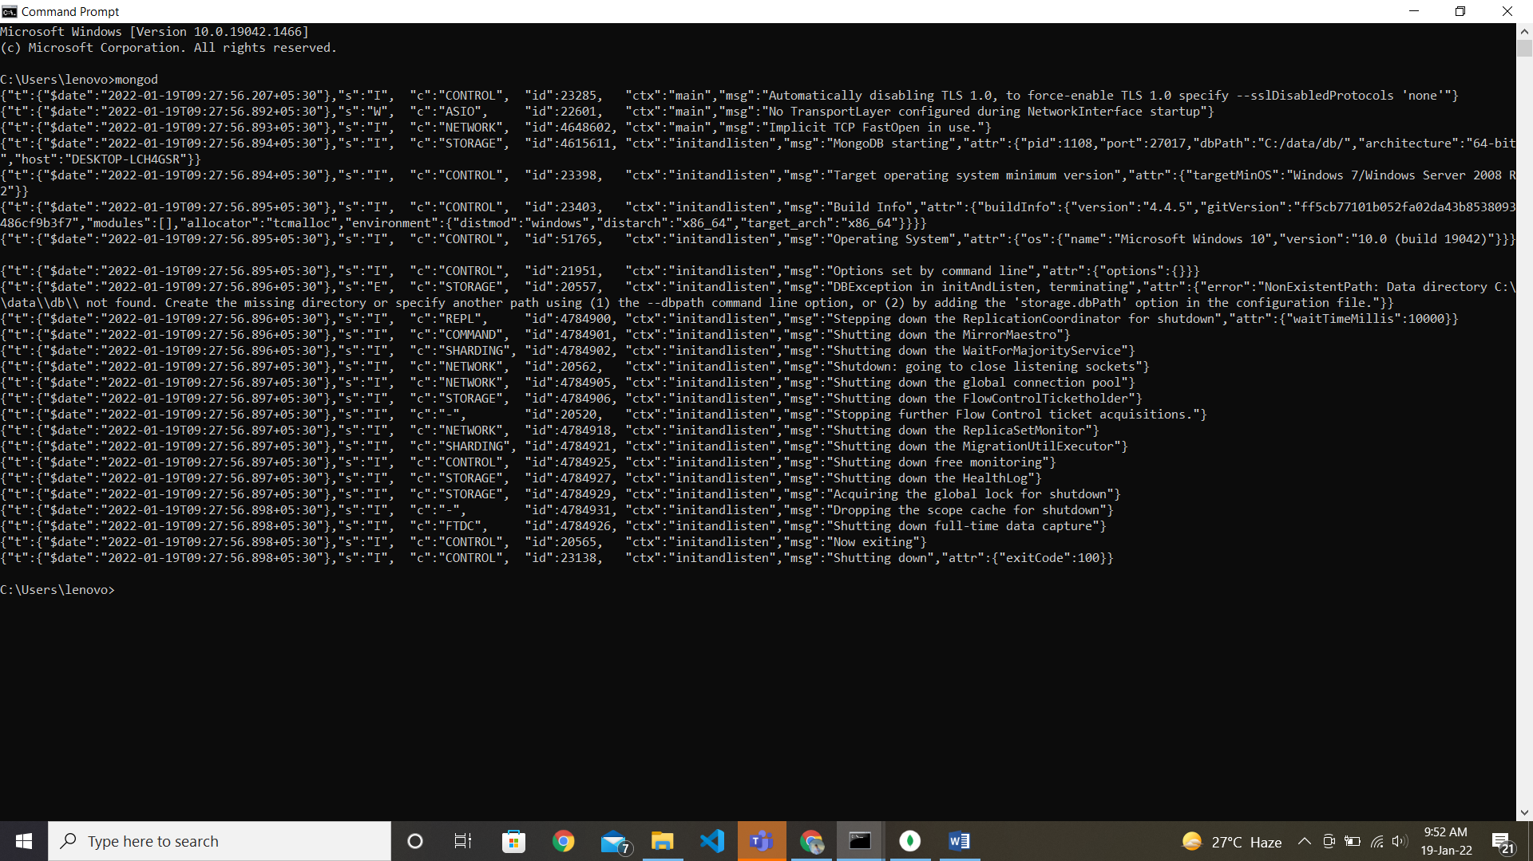

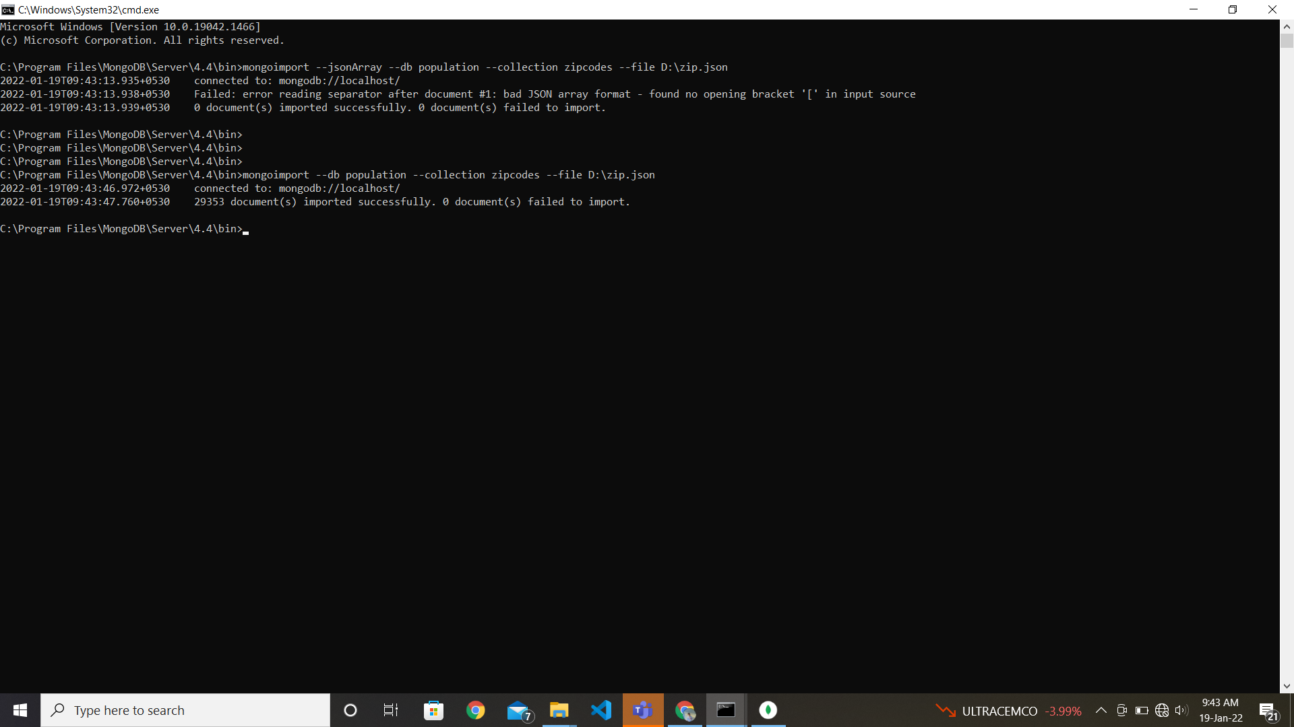

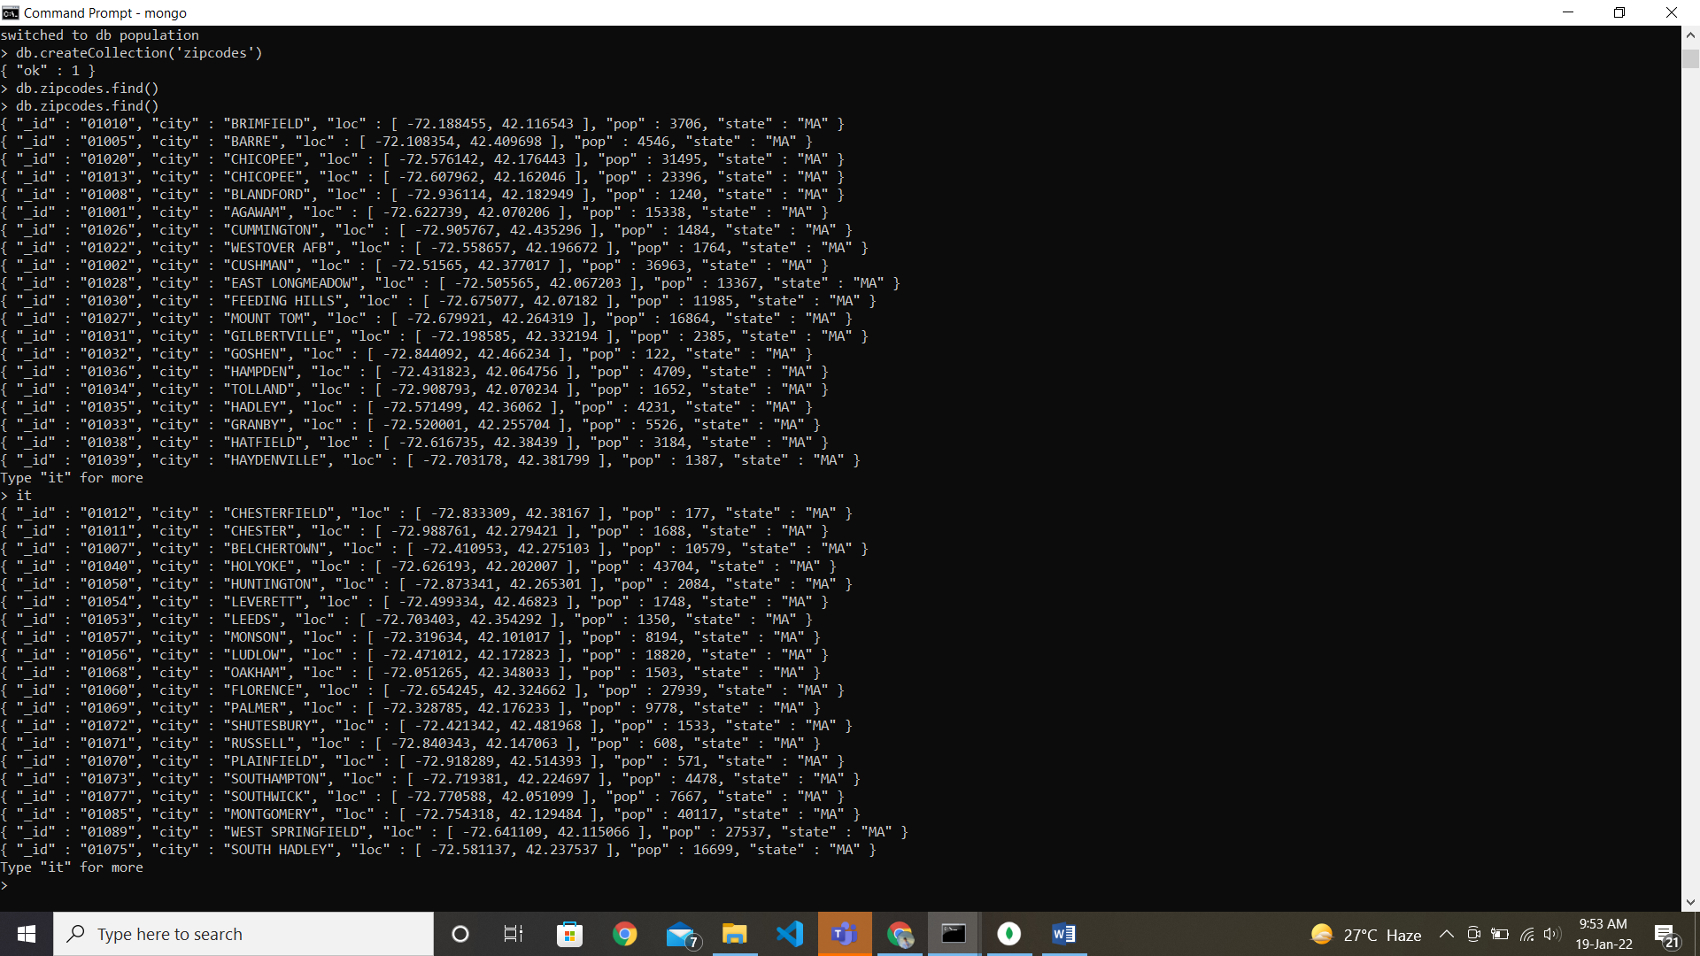

**Atlanta Population**

1. use db.zipcodes.find() to filter results to only the results where city is ATLANTA and state is GA.

* db.zipcodes.find({$and:[{city:"ATLANTA"},{state:"GA"}]})

2. use db.zipcodes.aggregate with Smatch to do the same as above.

* db.zipcodes.aggregate([{$match:{city:"ATLANTA",state:"GA"}}])

3, use $group to count the number of zip codes in Atlanta.

* db.zipcodes.aggregate([{$group:{"_id":"$city",count:{"$sum":1}}}])
* db.zipcodes.aggregate([{$match:{city:"ATLANTA"}},{$group:{"_id":"$city",count:{"$sum":1}}}])

4. use $group to find the total population in Atlanta,

* db.zipcodes.aggregate([{$match:{city:"ATLANTA"}},{$group:{"_id":"$city", totalpopulation:{"$sum":"$pop"}}}])

**Populations By State**

1. use aggregate to calculate the total population for each state

* db.zipcodes.aggregate([{$group:{ "_id":"$state",totalpopulation:{"$sum":"$pop"} }}])

2. sort the results by population, highest first

* db.zipcodes.aggregate([{$group:{ "_id":"$state",totalpopulation:{"$sum":"$pop"} }},{$sort:{totalpopulation:-1}}])

3. limit the results to just the first 3 results. What are the top 3 states in population?

* db.zipcodes.aggregate([{$group:{ "_id":"$state",totalpopulation:{"$sum":"$pop"} }},{$sort:{totalpopulation:-1}},{$limit:3}])

**Populations by City**

1. use aggregate to calculate the total population for each city (you have to use city/state combination). You can use a combination for the id of the $group: (city: $city', state: $state')

* db.zipcodes.aggregate([{$group:{ "_id":{city:"$city", state:"$state"},totalpopulation:{"$sum":"$pop"} }}])

2. sort the results by population, highest first

* db.zipcodes.aggregate([{$group:{ "_id":{city:"$city", state:"$state"}, totalpopulation:{"$sum":"$pop"} }},{$sort:{totalpopulation:-1}}])

3. limit the results to just the first 3 results. What are the top 3 cities in population?

* db.zipcodes.aggregate([{$group:{ "_id":{city:"$city", state:"$state"}, totalpopulation:{"$sum":"$pop"} }},{$sort:{totalpopulation:-1}}, {$limit:3}])

4. What are the top 3 cities in population in Texas?

* db.zipcodes.aggregate([{$match:{state:"TX"}}, {$group:{ "_id":{city:"$city"}, totalpopulation:{"$sum":"$pop"} }},{$sort:{totalpopulation:-1}}, {$limit:3}])

**Bonus**

1. Write a query to get the average city population for each state.

* db.zipcodes.aggregate([{$group: { "_id":{state:"$state"}, average:{"$avg":"$pop"} }}])

2. What are the top 3 states in terms of average city population?

* db.zipcodes.aggregate([{$group: { "_id":{state:"$state"}, average:{"$avg":"$pop"} }}, {$sort: {average:-1}}, {$limit:3}])